Multi-Boot USB Creation Using Ventoy

To create a multi-boot USB drive that allows installation of multiple operating systems (Windows 10, Windows 11, Ubuntu) from a single USB device.

Requirements
- Minimum 64GB USB Drive
- Ventoy software from browser.
ISO files:
UBUNTU OS FAMILY
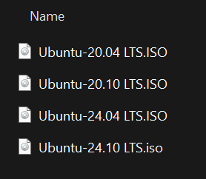

WINDOWS OS FAMILY
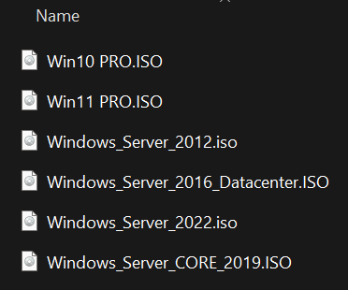

🔽 Step 1: Download Ventoy
- Open browser and go to official Ventoy website.
LINK: https://www.ventoy.net/en/download.html
- Download the latest Windows.zip file.
- Extract the downloaded ZIP file.

Step 2: Install Ventoy on USB
- Insert the USB drive into the system.
- Open extracted Ventoy folder.
- Right-click on Ventoy2Disk.exe → Select Run as Administrator.
- Select the USB drive from the device list.
- Click on Install.
- Confirm the warning messages (USB will be formatted).

Step 3: Copy ISO Files
- Open "This PC".
- Open the Ventoy USB drive.
- Copy and paste ISO files directly into the USB (no extraction required).
Example: Only ISO files like: -
  - Win10.iso
  - Win11.iso
  - Ubuntu.iso
- Optional: Create folders (Windows, Ubuntu) and store ISO files inside.

💻 Step 4: Boot from USB
- Insert USB into target laptop/desktop.
- Restart the system.
- Press boot menu key:
  - Dell → F12
  - HP → Esc / F9
  - Lenovo → F12
- Select USB device.

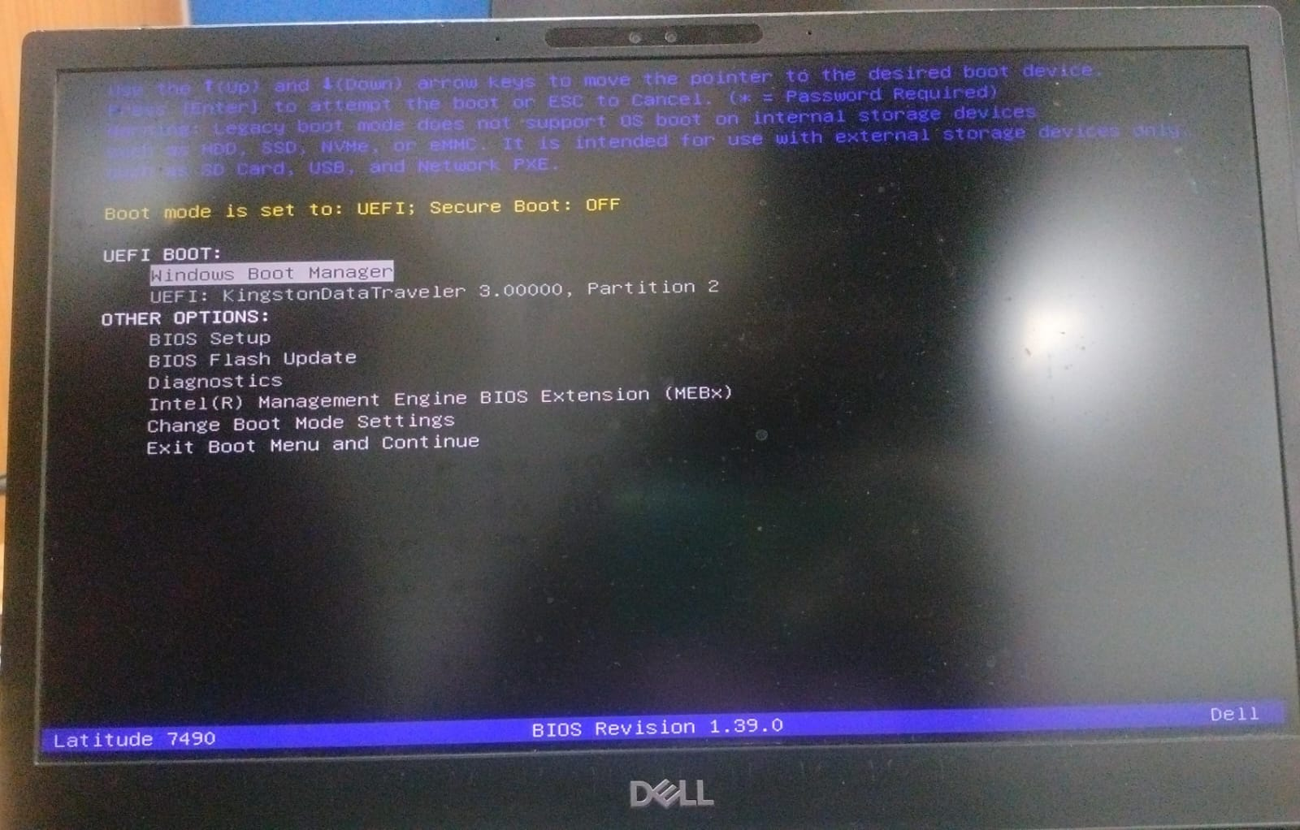

Step 5: Select Operating System
- Ventoy menu will appear.
- List of ISO files will be displayed.
- Select required OS.
- Choose Boot in Normal Mode.

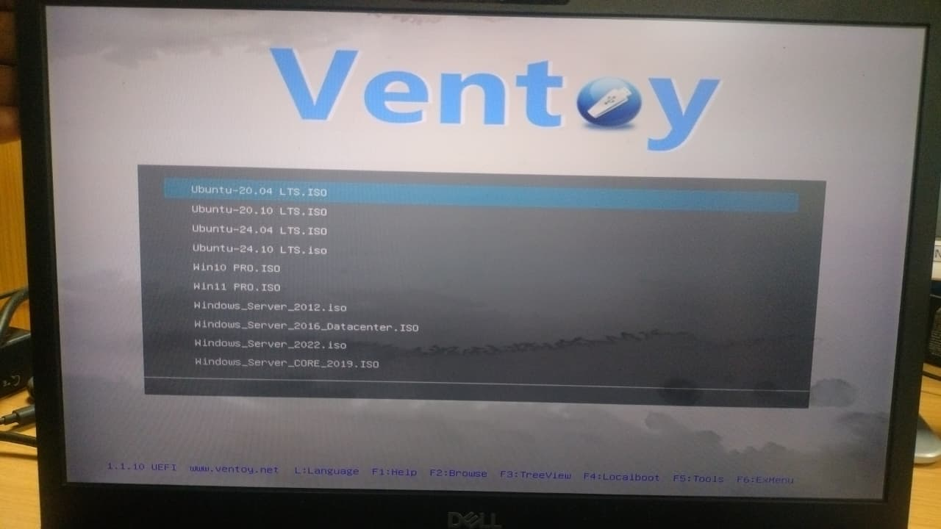

Important Notes
- ISO files should not be extracted.
- USB will be formatted during Ventoy installation.
- Ventoy setup is required only once.
- Additional ISO files can be added later without reinstallation.
- Both UEFI and Legacy BIOS are supported.

✅ Conclusion
Ventoy provides an efficient and flexible way to create a multi-boot USB drive. It eliminates the need to format the USB repeatedly and allows multiple operating systems to be managed easily.

